EMOTE S1 Wizard

Instructions

# Getting started

1. Talk to Aidan for correct installations.

# GitHub

1. Go to Github. Click Sync top right corner. Wait until done.
2. Open Jave Eclipse.
3. Stop Tomcat-server if running (bottom left box).
4. In Project window top left – right-click on Project EmoteMaps > Refresh.
5. In menu field, click Project > Clean.

# Start Wizard

1. Open a web browser, e.g. Firefox or Chrome.
2. Go to <http://localhost:8080/namshub>
3. In the menu > Mode > Scenario Maker Wizard
4. Refresh browser
5. Close menu by clicking Menu button at the bottom.

# Tools

The tools are used to map out the trail. For example, you need to measure a distance before writing a task step with distance.

To measure:

1. Click **Distance Tool** > click where you want to measure from > click again where you want to measure to > if measuring a curved path, click at each angle point (see example) > make note of measurement > click Distance Tool to close.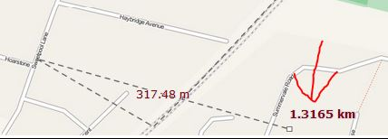

To check available symbols:

1. Click **Map Key** > click map key to close.

To check the direction:

1. Click on **compass** to open > click on compass to close.

# Create a scenario trail step by step

1. **Set location** > Choose map
2. **Scenario** > Write Scenario name > Get or Create Scenario – Green center point appears. This can be dragged around the map. 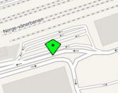
3. **Navigation and step text** > Write step on screen text (see example) > Write Step Speech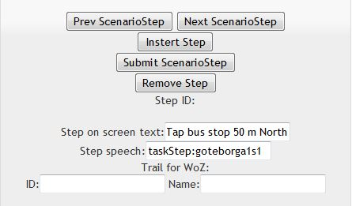
   1. Click Submit ScenarioStep
4. **Step type** > Click
5. **Navigation and step text** > Submit ScenarioStep.
6. **Step requirements** > Tick appropriate boxes and fill in. Always write in meters, i.e. 1 km would be written as 1000. Lower case direction and symbol as is written in Step detail set up.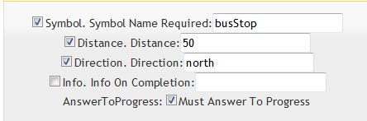
   1. If step ends with a clue then: 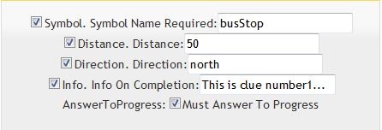
7. **Navigation and step text** > Submit ScenarioStep.
8. **Step detail set up** > click Add reference > click Add target(can place anywhere by dragging)
   1. Reference is the starting point for the step (red star); it is movable by dragging.
   2. Target is the target or correct answer for the step (green star); movable by dragging.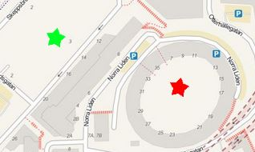
9. In **step detail and set up**, add the symbols that you want on the map by placing the green center point where you want the symbol to appear > click on name of symbol > click Add symbol at marker for activity > Submit ScenarioStep. Repeat.
   1. To delete a symbol > click Delete Mode On > click on the symbol to remove > click Delete Mode Off.
   2. To delete a reference or target > click Remove Reference or Remove Target.
   3. To place reference or target off screen (you cannot pan around the map) > hit CTRL - to zoom out > move stars to correct location > Submit ScenarioStep > the map is now centered at the red reference star > hit CTRL + to zoom back in.
10. **Navigation and step text** > click Next ScenarioStep > Make sure Step ID is now 1 > Repeat steps 3-10. > Make sure Step ID is now 2, etc. 